

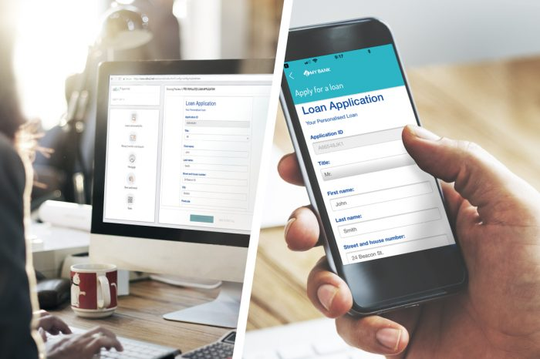

The CallVU Digital Engagement Platform

The CallVU Digital Engagement Platform automates business processes by maximizing digital usage in any interaction to reduce costs, improve service quality and increase sales conversion. The comprehensive platform ensures higher issue resolution, reduced call volumes, and enhanced customer experiences.

The platform makes an ideal solution for financial, telecommunication, insurance and other service industries that are dependent on call centers as the primary point of contact with their customers.

# Create. Publish Engage.

CallVU’s Digital Engagement Platform unifies disparate organizational activities into a seamless comprehensive process. The result is a productive and appealing user experience at every point of engagement

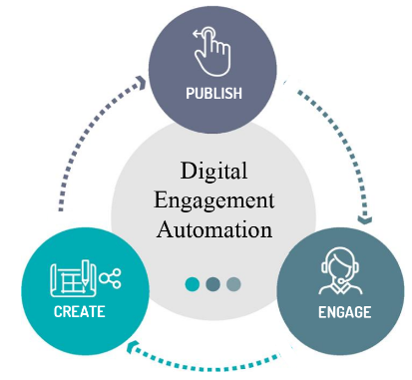

**Create**

Bestowing the platform with endless flexibility, communication flows, screens, and digital documents can be easily created and edited to address limitless process requirements.

**Publish**

All material is published to an omni channel environment that ensures customers consume a seamless and consistent customer experience, even if changing digital channels, or devices, mid-process.

**Web/App** - Incorporate forms and documents into existing digital channels to create a comprehensive omnichannel engagement platform.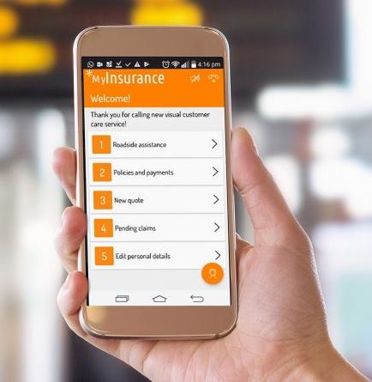

**Agent Portal** - Publish automated process flows, documents and forms to the agent’s portal, so that all material is accessible to agents as they support customers through any service issue. The agent portal seamlessly integrates with back-end organizational systems so that information previously provided by the customer is automatically populated to any type of new form.

To operate the agent portal, please contact us at: info@callvu.com

**Visual and Conversational IVR** – Powering the IVR with visual display menus to enable callers to immediately arrive at the relevant service destination. Automated process flows, visual screens and digital forms can all be published to the Visual and Conversational IVR interface. Visual depictions include display text, images and videos, all of which provide clarity and enhance the user experience. Service providers can add branding, and product promotions to enrich communication.

**Engage**

The digital customer engagement platform is designed to support quality customer experiences through superior engagements that foster strong customer loyalties.

**Agent Caller Collaboration** - Enable agents to work collaboratively with customers by being able to share rich media, such as forms, and images have live video chats. This ensures a fast resolution of issues and more efficient conversations for both inbound and outbound customer sales interactions.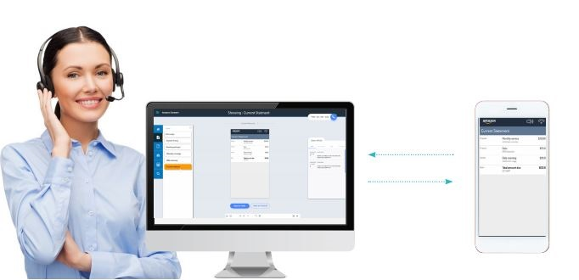

**Smart Digital Forms -** Created forms can be embedded in web pages, apps or provided as PDFs, mobile wizards etc.

To start using our digital forms portal, please contact us at: info@callvu.com

**Digital Self Service over the phone** - Equip customers with clear and coherent pathways that enable them to complete activities and resolve any number of issues in self-service.

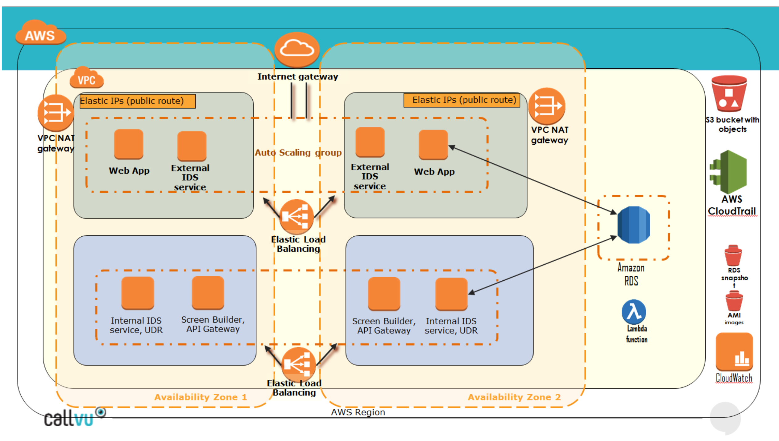

**The integration creates the following**:

* A highly available architecture that spans multiple Availability Zones.
* 2 Auto Scale Group instances running Amazon Elastic Compute Cloud (Amazon EC2) with Windows Server 2016, to host the CallVU core services and web applications.
* An Amazon Relational Database Service (Amazon RDS) for SQL Server DB instance to synchronize the traffic between the private and public subnets; to store CDRs for reporting services
* An Amazon Simple Storage Service (Amazon S3) bucket for storing CloudTrail files.
* Lambda function as an interface to the digital engagement platform
* SNS client for sending text messages

**To integrate CallVU’s Digital Engagement Platform with Amazon Connect**

* Step 1: Sign up for an AWS account, if you don't already have one.

Getting an account will automatically sign you up for Amazon Connect and all other AWS services.

* Step 2: Create a new Amazon Connect instance for the integration, or use an existing instance.
* Step 3: Deploy the integration.

Complete the parameter fields. Deployment takes about an 1 hours and 30 minutes. You can deploy the Quick Start in all AWS Regions with Amazon Connect support (N. Virginia, Oregon, Sydney, Frankfurt) and Ohio.

* Step 4: Test the integration
  1. Open  the Connect flow template from <https://callvu.net/documentation/SampleFlow.txt> in text editor.
  2. Copy the ARN of the Lambda function from Outputs in Formation window

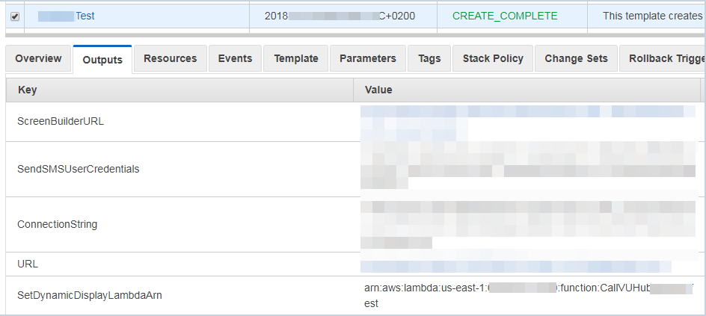

* 1. In the connect flow you have downloaded replace all occurrences of "SetDynamicDisplay ARN HERE" with the actual Lambda ARN (from previous step) .
  2. Make the ARN discoverable by connect as detailed in the following url:  
     <https://docs.aws.amazon.com/connect/latest/adminguide/connect-lambda-functions.html>  
     In order to run the command in the above instructions you would need to download the AWS CLI. It is available for download at: <https://aws.amazon.com/cli/>
  3. Import the flow to your connect account Contact Flows and "Save & Publish" it.
  4. Assign a phone number to that flow. In the connect Dashboard choose "View phone numbers", then assign a number.



* 1. Create DNS mapping between your external domain Url to the address of the external load balancer that can be found at Output of Formation under URL section.
  2. Make a call to that number to ensure you receive a text message (SMS). Click on the link within the text message and get a visual screen.
  3. Congratulations!!!
* Follow the instructions in the [AWS Visual Connect Guide](callvu-connect/documentation/AWS%20Visual%20Connect%20manual.docx) to create your own Visual IVR.

## How to contact us:

Email: info@callvu.com

Website: callvu.com